Workshop on pharmacology and toxicity of new psychoactive substances
organised in co-operation with the Office for Combating Drug Abuse of the Republic of Croatia

Venue: Zagreb
Panorama Zagreb Hotel, Trg Krešimira Ćosića 9
16 - 17 March 2015

Beneficiary:

Croatia

JHA 57361

Aim of the meeting:
The Workshop aims at providing in-depth insight into pharmacology and toxicity of individual new psychoactive substances (NPS) to key stakeholders in the future clinical-toxicological network of the national Early Warning System (EWS) on NPS in Croatia. The goal is to develop early recognition of signs and symptoms of NPS intoxications, which will contribute to increasing the quality of treatment and ultimately to saving lives of intoxicated drug users.

In recent years Croatia has been facing increased availability of a wide spectrum of novel psychoactive substances, many of which are not subject to control measures. At the same time, proportions of adverse health effects related to the use of NPS in Croatia are completely unknown. It is therefore essential to develop a sustainable infrastructure for monitoring adverse health consequences of NPS use, including incising scientific and professional capacities of clinical toxicology laboratories, emergency wards and other relevant subjects in the health sector responsible for identification of NPS in biological samples and effective treatment of intoxicated persons.

The target group of the Workshop are representatives of the Office for Combating Drug Abuse of the Government of the Republic of Croatia, Ministry of Health, the Croatian Institute of Emergency Medicine, the County Institutes of Emergency Medicine and Clinical Hospitals (emergency, psychiatric and paediatric departments).

The Workshop will contribute to setting up an effective and sustainable mechanism for monitoring of and responding to intoxications caused by NPS in the framework of EWS.

Day 1: Monday 16 March 2015

Chair: Ms Lidija Vugrinec, Head of Department for International Relations, Office for Combating Drug Abuse

08:30  -  09:00 | Registration of participants
09:00 | Welcome and opening remarks  Mr Željko Petković  Director of the Office for Combating Drug Abuse
09:15 | Introduction to the Workshop: the role of the health system in the Croatian Early Warning System and the development of the clinical-toxicological network  Ms Lidija Vugrinec  Head of Department for International Relations  Office for Combating Drug Abuse
09:45 | Novel sources of data on new psychoactive substances  Dr David Wood  Consultant Physician and Clinical Toxicologist, Clinical Lead for Medicine  Guy’s and St Thomas’ NHS Foundation Trust, UK
10:15 | Questions and answers
10:30 | Coffee break
11:00 | Toxicokinetics of new psychoactive substances  Dr Markus R. Meyer  Deputy Head of Department of Experimental & Clinical Toxicology  Saarland University, Germany
11:30 | Questions and answers
11:45 | An update in the toxicity of novel hallucinogenics and synthetic cannabinoids  Dr David Wood  Consultant Physician and Clinical Toxicologist, Clinical Lead for Medicine  Guy’s and St Thomas’ NHS Foundation Trust, UK
12:15 | Questions and answers followed by a discussion
13:00 | Lunch
14:00 | The role of the Poisons Information Service in monitoring NPS  Dr John Thompson  Director of the UK Poisons Information Service
14:30 | Questions and answers
14:45 | The role of the Swedish Poisons Information Centre in monitoring NPS and challenges in laboratory testing for NPS  Dr Matilda Bäckberg  Swedish Poisons Information Centre
15:15 | Questions and answers
15:30 | Analytical techniques for the detection of NPS and their metabolites  Dr John Thompson  Director of the UK Poisons Information Service
16:00 | Croatian experience in detecting NPS – poisoning index  MSc Rajka Turk  MPharm  Representative of the Institute of Medical Research  Centre for Poisoning, Croatia
16:30 | Questions and answers followed by a discussion
17:00 | Conclusions

Day 2: Tuesday 17 March 2015

Chair: Ms Lidija Vugrinec, Head of Department for International Relations, Office for Combating Drug Abuse

08:30  -  09:00 | Registration of participants
09:00 | Improved laboratory testing for NPS  Dr Matilda Bäckberg  Pharmacist  Swedish Poisons Information Centre
09:30 | Questions and answers
09:45 | An update in the toxicity of new stimulants  Dr Paul Dargan  Consultant Physician and Clinical Toxicologist  Clinical Director and Reader in Toxicology  Guy’s and St Thomas’ NHS Foundation Trust, UK
10:15 | Questions and answers
10:30 | Coffee break
11:00 | Pre-hospital assessment and management of new psychoactive substance toxicity  Dr Paul Dargan  Consultant Physician and Clinical Toxicologist  Clinical Director and Reader in Toxicology  Guy’s and St Thomas’ NHS Foundation Trust, UK
11:45 | Questions and answers
12:00 | Discussion
13:00 | Lunch
14:00 | NPS related intoxications in Croatia - Experience from the practice  Dr Jasmin Hamzić  Emergency Department Resident  University Hospital Centre Zagreb
14:30 | Questions and answers
14:45 | Recommendations for setting up analytical methods for analysis of NPS in Croatia  Dr Paul Dargan  Consultant Physician and Clinical Toxicologist  Clinical Director and Reader in Toxicology  Guy’s and St Thomas’ NHS Foundation Trust, UK  Dr Markus R. Meyer  Deputy Head of Department of Experimental & Clinical Toxicology  Saarland University, Germany  Dr Matilda Bäckberg  Pharmacist  Swedish Poisons Information Centre
15:30 | Discussion of recommendations and follow-up
17:00 | Conclusions

This meeting is being organised by the Technical Assistance Information Exchange Instrument (TAIEX) of the European Commission

Presentations can be consulted through the following link (enter 57361 under "Select Event"): http://ec.europa.eu/neighbourhood-enlargement/taiex/dyn/taiex-events/index_en.jsp
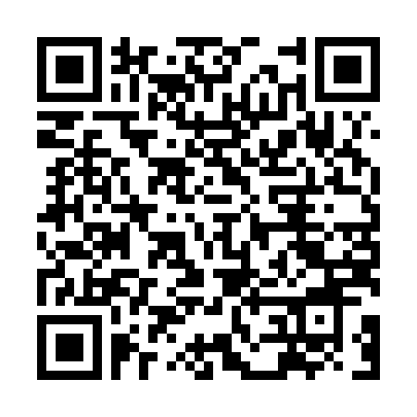
TAIEX on Twitter: #EUTaiex
NEAR-Taiex@ec.europa.eu; Telephone: +32-2-296 73 07

